5 FACTS ABOUT POVERTY IN FINLAND

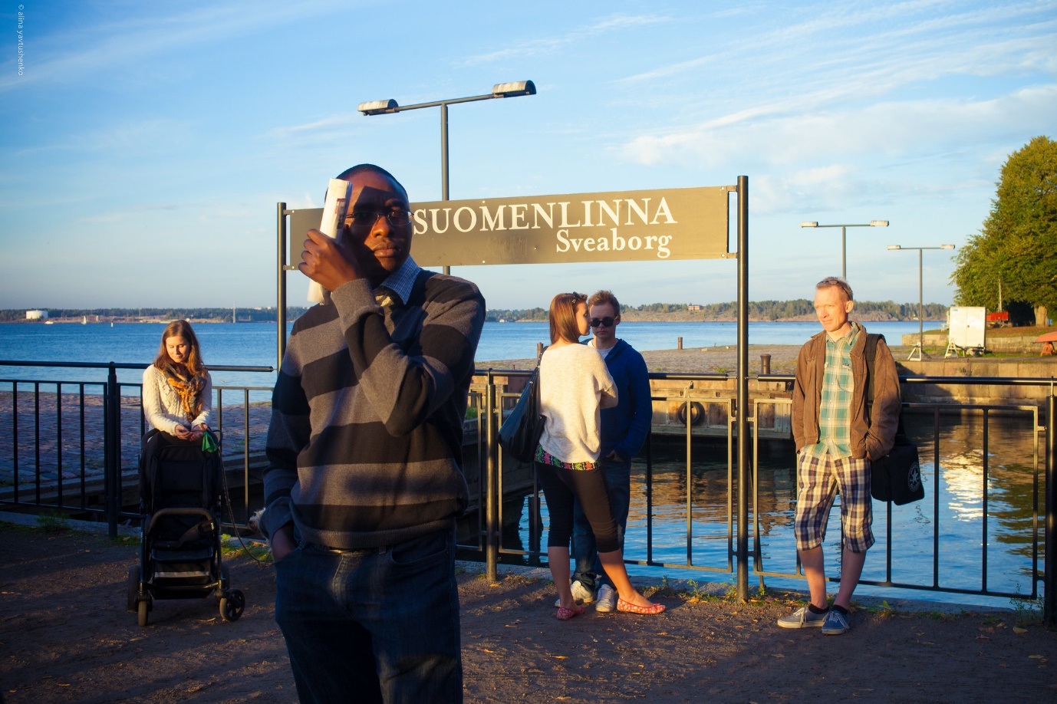Many know Finland as one of the happiest countries around the world. Not only do people know Finland for the iconic Northern Lights, but they also consider it to be one of the least poverty-stricken countries in all of Europe. Finland has the [fourth-lowest poverty rate](https://data.oecd.org/inequality/poverty-rate.htm#indicator-chart) in OCED countries and a Gini coefficient of .27, which is lower than the United States. Here are five facts about poverty in Finland.

5 Facts About Poverty in Finland

1. **Finland has a high quality of life.** In fact, Finland has one of the highest quality of life scores in Europe. Its score of [8.2 out of 10](https://www.eurofound.europa.eu/country/finland) is higher than the average 7.4 rate in the European Union as of 2016. People are generally happier in Finland and the number has stayed consistent since 2003.
2. **Finland’s unemployment rate** **was**[**approximately 7%**](https://www.macrotrends.net/countries/FIN/finland/unemployment-rate)**as of 2018.** This is a huge improvement over the last couple of years, where the unemployment rate was close to 10% in 2014. Since then, the unemployment rate has dropped to a little [more than 6%](https://www.statista.com/statistics/268830/unemployment-rate-in-eu-countries/) as of January 2020. This number is significantly lower than Finland’s youth unemployment rate which was close to 17% in 2017, but it is a huge improvement from its 2016 youth unemployment rate of nearly 20%.
3. **Finland’s GDP per capita** **has been steadily increasing over the years.** Finland’s GDP per capita has increased [by over 8%](https://data.worldbank.org/indicator/NY.GDP.PCAP.CD?locations=FI) from 2017 to 2018. Finland ranks as having one of the highest GDP per capita with numbers higher than countries including Canada, France and the United Kingdom.
4. **Finland’s education system** **has been improving since the 1970s.** Finland ranks first out of all OCED countries on the PISA test. The PISA is an academic test in language, math and science that 15-year-old kids take internationally. Many attribute Finland’s successful education system to its [investment in teachers’ education](https://edpolicy.stanford.edu/library/publications/543). Over half of Finland’s adult population finish some form of education which could be due to the fact that Finland’s government pays for close to 100% of the cost of education.
5. **Finland’s child poverty rate** **is one of the lowest in OCED countries.** Finland has a child poverty rate of 4%, compared to the U.S. child poverty rate of 20%. This is due to Finland [shifting welfare policies](https://www.sgi-network.org/2017/Finland/Social_Policies) from local government to big government by providing mothers with public daycare and allowances for children under the age of 17. Finland’s child poverty rate is not only lower than the United States but also Germany, Sweden and Australia.

The probability of someone becoming poor in Finland is actually lower than the probability of them becoming poor in all of Europe. In 2016, the chance of someone in Finland being at risk of poverty was [approximately 16%](https://www.stat.fi/til/eot/2017/eot_2017_2019-05-24_tie_001_en.html) compared to 22% in the European Union as of 2019. Finland also has one of the highest Human Development Indexes (HDI) with a [placement of number 12](http://hdr.undp.org/sites/all/themes/hdr_theme/country-notes/FIN.pdf) out of 189 countries. Its HDI has been increasing for nearly two decades now and sits at a .925 as of 2018. One can attribute Finland’s success as a country to an increased life expectancy at birth since 1990, an increased number of expected and mean schooling since 1990 and an increase in its Gross National Income (GNP) per capita since 1990. These five facts about poverty in Finland show that overall, Finland is one of the most prosperous countries in Europe due to the exceptional education system, low poverty rate and an expanding economy.

Referencing

Finland .:. Sustainable Development Knowledge Platform. (n.d.). Https://Sustainabledevelopment.Un.Org/Memberstates/Finland. Retrieved January 13, 2022, from <https://sustainabledevelopment.un.org/memberstates/finland>

(Finland .:. Sustainable Development Knowledge Platform, n.d.)